Alpha Research — Strategy Families
Momentum, Mean Reversion, Statistical Arbitrage, Carry, Value, Quality, Volatility, Event-Driven, Seasonality, and Relative-Value Trading
The Canonical Signal Families of Systematic Trading, and Why Each One Should Work
A Level 3 module in the Quantitative Finance Curriculum
Covers: momentum (cross-sectional & time-series) · mean reversion/trend following · pairs trading/statistical arbitrage · carry/value/quality · volatility signals · event-driven signals · seasonality · relative value/basis trading/funding arbitrage · cross-venue arbitrage

Table of Contents
How to Use This Guide
What You Need to Know Before Starting
Understand Before Proceeding
Why It Matters
How This Connects to the Rest of the Curriculum
Glossary of Recurring Terms
Part 1 — Momentum and Mean Reversion: The Two Basic Regimes
1.1 Time-Series Momentum (Trend Following)
1.2 Cross-Sectional Momentum
1.3 Mean Reversion
1.4 Reconciling Momentum and Mean Reversion: The Horizon Spectrum
Part 2 — Pairs Trading and Statistical Arbitrage
2.1 The Pairs Trading Framework
2.2 Cointegration, Spread Construction, and Half-Life
2.3 Statistical Arbitrage at Scale
Part 3 — Carry, Value, and Quality
3.1 Carry
3.2 Value
3.3 Quality
Part 4 — Volatility and Event-Driven Signals
4.1 Volatility Signals
4.2 Event-Driven Signals
Part 5 — Seasonality, Relative Value, and Cross-Venue Arbitrage
5.1 Seasonality
5.2 Relative Value, Basis Trading, and Funding Arbitrage
5.3 Cross-Venue Arbitrage
Practical Exercise
Common Beginner Mistakes
Advanced Extensions
Professional Applications
Where to Go Next

How to Use This Guide
This document is a companion to Alpha Research — Strategy Families, the Level 3 module that catalogs the canonical families of systematic trading signals — the recurring patterns that show up, in one form or another, in almost every systematic hedge fund's and proprietary trading desk's signal library. Each family gets the same treatment: what the signal is, the economic rationale for why it should earn a return, a worked numerical example, and the conditions under which the edge decays or disappears.
The organizing idea of this module is in the title of the next section: understanding why a strategy family should work is what lets you anticipate when it will stop working. Read it start to finish to get the full landscape of strategy families before specializing, or jump to the family most relevant to what you are building — but do not skip Understand Before Proceeding below.

What You Need to Know Before Starting
- Time Series — stationarity, autocorrelation, and the basic language of describing how a series behaves over time; several strategy families are literally statements about the autocorrelation structure of returns.
- Regression — ordinary least squares, R², and reading a regression coefficient as a sensitivity; used throughout to define and evaluate signals (e.g., factor regressions, cointegrating regressions).
- Statistics — hypothesis testing, p-values, and enough awareness of multiple-testing problems to be skeptical of a strategy that only 'discovered' its edge by trying many variations.
- Risk Metrics — Sharpe ratio, drawdown, and volatility, since every strategy family in this module is evaluated on risk-adjusted terms, not raw return.

Understand Before Proceeding
Prerequisite gate — Do not treat a backtest's Sharpe ratio as sufficient justification for trading a strategy. Every family in this module is presented with its economic rationale first and its evidence second, deliberately — a strategy with no story for why the edge should exist, and why other sophisticated participants have not already competed it away, is not research. It is pattern-matching on historical noise, and it is the single most common failure mode among self-taught quants, precisely because a large enough universe of possible signals guarantees that some of them will look profitable purely by chance.

Why It Matters
Understanding why a strategy family should work — its economic rationale — is what allows you to anticipate when and why it will stop working. This is the difference between research and data mining. A momentum strategy that works because underreaction to news takes time to correct will decay as more capital chases the same signal and speeds up that correction; a carry strategy that works because it compensates for crash risk will suffer its worst losses exactly when that risk materializes, not randomly. Neither of these facts is visible in a backtest's summary statistics — both are visible the moment you understand the underlying mechanism.
This matters commercially as much as intellectually: every strategy family below has a different capacity (how much capital it can absorb before its own trading erodes the edge), a different turnover (how often it trades, and therefore how sensitive it is to costs), and a different crowding dynamic (how fast other participants can discover and compete away the same edge). Confusing a low-capacity, fast-decaying signal with a scalable, durable one is an expensive mistake made at the strategy-selection stage, before a single dollar is risked.

How This Connects to the Rest of the Curriculum
- Research — This is the research track's core subject matter; every strategy family requires its own data, signal-construction, and validation approach, detailed per-strategy throughout Parts 1–5.
- Development — Each strategy family implies different data latency, universe size, and computation requirements — a cross-sectional equity momentum strategy needs a wide, slowly-updating universe; a cross-venue arbitrage strategy needs a narrow, microsecond-latency one.
- Trading — Different strategy families have very different capacity, turnover, and execution-sensitivity profiles — a monthly-rebalanced value strategy tolerates execution slop that would destroy a cross-venue arbitrage strategy outright.

Glossary of Recurring Terms
Time-series momentum — A strategy that goes long an asset that has recently risen and short (or flat) one that has recently fallen, using only the asset's own historical price path — also called trend following.
Cross-sectional momentum — A strategy that ranks a universe of assets by recent relative performance and goes long the top performers while shorting the bottom performers.
Mean reversion — A strategy that bets a price or spread will move back toward a historical or statistical average after deviating from it.
Pairs trading — A market-neutral strategy that trades the spread between two historically related securities, long the relatively cheap one and short the relatively expensive one.
Statistical arbitrage (stat arb) — The systematic, often large-scale generalization of pairs trading to many simultaneous relative-value positions, typically model- rather than story-driven.
Cointegration — A statistical property of two or more non-stationary price series whose linear combination (the spread) is itself stationary — the formal basis for pairs trading.
Carry — The return earned (or paid) simply from holding a position over time if prices do not move at all, arising from yield, dividends, interest-rate differentials, or futures roll.
Value — A strategy that buys assets that are statistically cheap relative to a fundamental anchor (earnings, book value, cash flow) and sells or avoids those that are expensive.
Quality — A strategy that favors financially healthy, stable, profitable businesses (or issuers) over weaker ones, largely independent of price.
Volatility risk premium — The tendency of implied (option-priced) volatility to exceed subsequently realized volatility, compensating option sellers for bearing tail risk.
Event-driven signal — A signal keyed to a discrete, scheduled or unscheduled corporate or macro event (earnings, M&A, index reconstitution) rather than to a continuous price series.
Post-earnings-announcement drift (PEAD) — The empirical tendency for a stock's price to continue drifting in the direction of an earnings surprise for weeks after the announcement.
Seasonality — A recurring pattern in returns tied to the calendar — time of month, time of year, day of week — rather than to any specific fundamental event.
Relative value — A broad category of strategies that trade the price relationship between two related instruments rather than taking an outright directional view on either.
Basis trading — A relative-value strategy that trades the gap (the basis) between a futures price and the underlying spot price, which must converge to zero at expiry.
Funding arbitrage — A relative-value strategy that captures the funding-rate payment on perpetual futures or similar instruments by holding an offsetting spot or futures position.
Cross-venue arbitrage — A strategy that captures temporary price discrepancies for the same (or economically identical) instrument trading simultaneously on two or more venues.
Crowding — The extent to which many participants hold or pursue the same or highly correlated positions, which can amplify losses and unwind speed when the trade reverses.
Decay — The tendency of a strategy's edge to shrink over time, whether from crowding, structural market change, or the original rationale ceasing to apply.

Part 1 — Momentum and Mean Reversion: The Two Basic Regimes
Momentum and mean reversion are, in a sense, opposite bets — one says a recent move will continue, the other says it will reverse — yet both are well-documented, persistent empirical patterns, because they operate over different horizons and through different economic mechanisms. This part covers both forms of momentum, mean reversion, and how the two are reconciled into a single picture of return predictability across horizons.

1.1 Time-Series Momentum (Trend Following)
Time-series momentum uses only an asset's own price history: if it has risen over some lookback window, go long; if it has fallen, go short (or move to cash). The simplest implementation compares a fast and a slow moving average and trades the crossover; more sophisticated versions use volatility-adjusted returns, multiple timeframes, or channel breakouts, but the underlying logic is unchanged.
Signal = sign(Price(t) − Price(t − lookback)), or sign(MA_fast(t) − MA_slow(t))
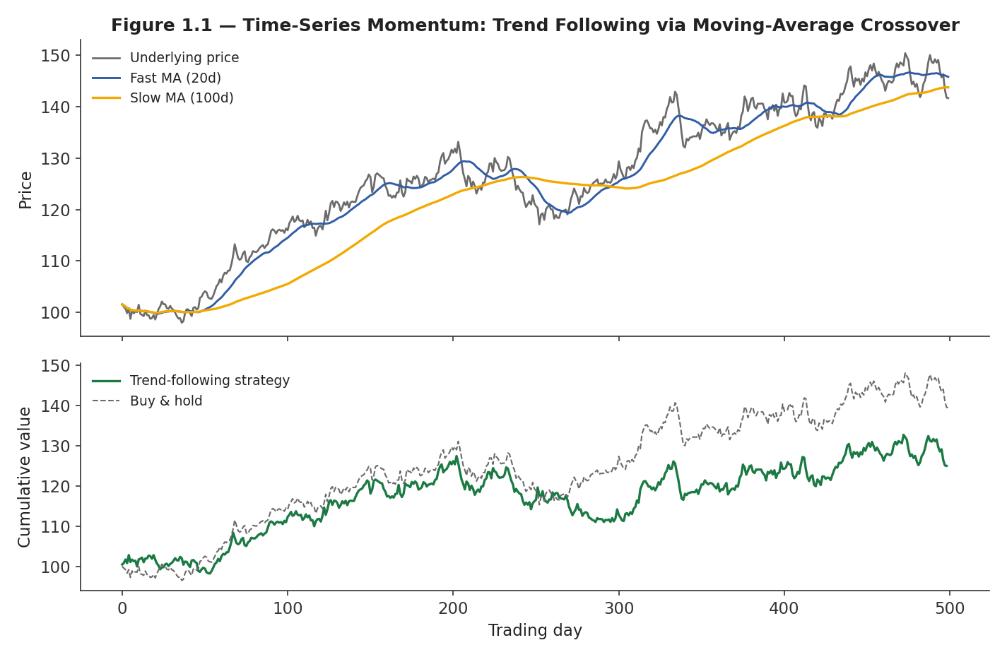
Figure 1.1 — Time-series momentum: a fast/slow moving-average crossover generates long and short signals; the strategy captures a share of sustained trends but whipsaws during choppy, range-bound periods.
The economic rationale rests on underreaction: new information diffuses into a price gradually rather than instantaneously, because of investor behavioral biases (anchoring, disposition effect), the slow flow of information across different types of investors, and institutional frictions (mandates that force gradual rebalancing, risk limits that delay position changes). Time-series momentum is one of the most extensively documented effects across asset classes — equities, commodities, currencies, and bonds — and across a century or more of data, which is part of what makes it a canonical strategy family rather than an idiosyncratic pattern in one market.
Tip — Time-series momentum tends to have a distinctive, convex payoff profile: it loses small amounts frequently during choppy markets but earns large gains during sustained trends, including sharp drawdowns in other assets — which is why trend-following strategies are often discussed as a portfolio diversifier and crisis hedge, not purely as a source of standalone return.

1.2 Cross-Sectional Momentum
Cross-sectional momentum ranks a universe of assets by their return over a formation period (commonly 3–12 months, sometimes skipping the most recent month to avoid short-term reversal effects) and goes long the top-ranked decile while shorting the bottom-ranked decile, holding for a subsequent period before re-ranking. Unlike time-series momentum, the position is relative — it says nothing about whether the whole universe will rise or fall, only that recent winners will keep outperforming recent losers.
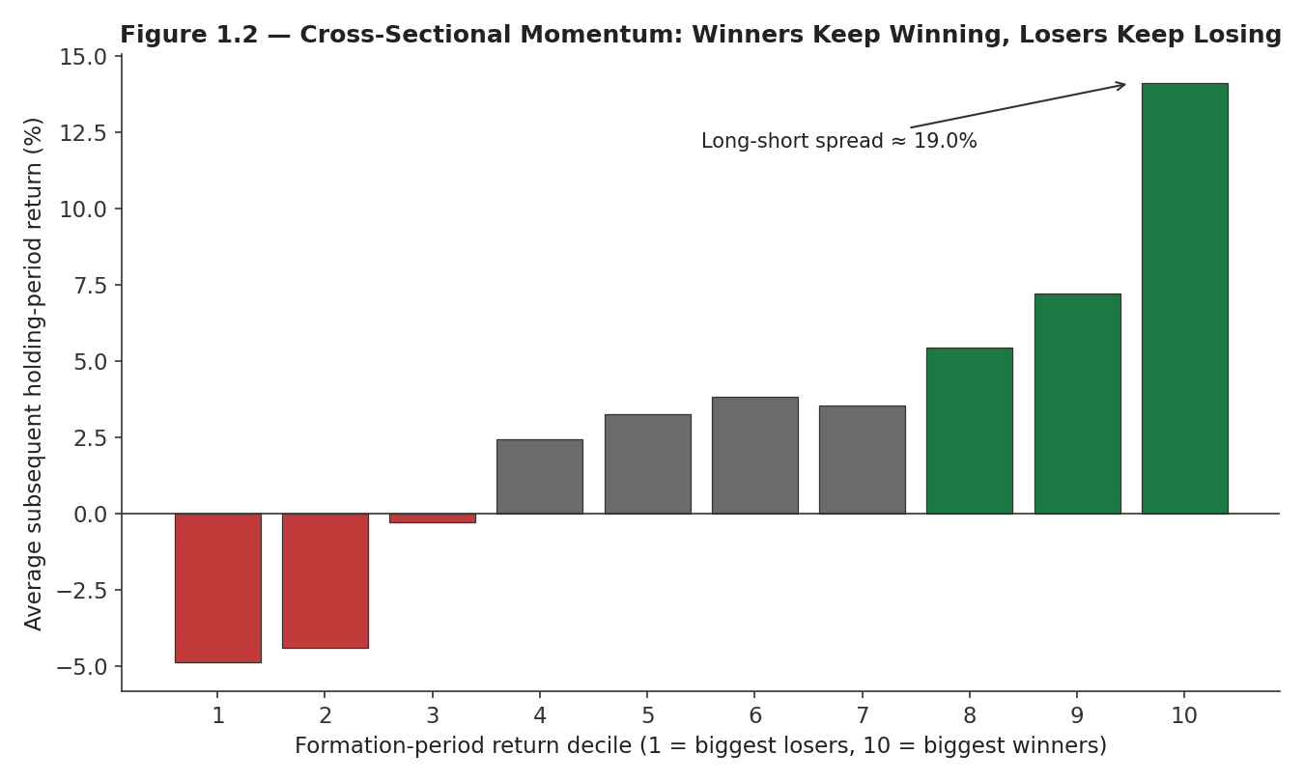
Figure 1.2 — Cross-sectional momentum: assets ranked by recent (formation-period) return continue, on average, to earn returns in the same relative direction over the subsequent holding period.
Worked example — A universe of 200 stocks is ranked by trailing 12-month return (skipping the most recent month) and split into deciles. If decile 10 (biggest winners) earns an average 6% over the next quarter and decile 1 (biggest losers) earns −5%, a long-decile-10/short-decile-1 portfolio captures an 11% spread before costs — the basic construction behind essentially every published cross-sectional momentum study.
The economic rationale overlaps with time-series momentum's underreaction story, but adds a relative dimension: information about a specific company or sector diffuses at different speeds to different types of investors (sell-side analysts, retail investors, index funds), so a stock's relative ranking versus its peers continues to adjust for months after the triggering news. Cross-sectional momentum is also the strategy family most associated with severe, sudden momentum crashes — sharp reversals, typically following a market rebound after a downturn, when previously beaten-down (heavily shorted) stocks rally hard all at once.

1.3 Mean Reversion
Mean reversion strategies bet that a price, spread, or other statistic will move back toward a historical or statistically estimated average after deviating from it — the opposite premise of momentum, and typically operating over much shorter horizons (intraday to a few weeks) or on more mean-reverting objects than raw single-asset prices (spreads, ratios, valuation multiples).
Z-score = (Value(t) − Rolling mean) / Rolling standard deviation; trade when |Z| exceeds a threshold, exit toward zero
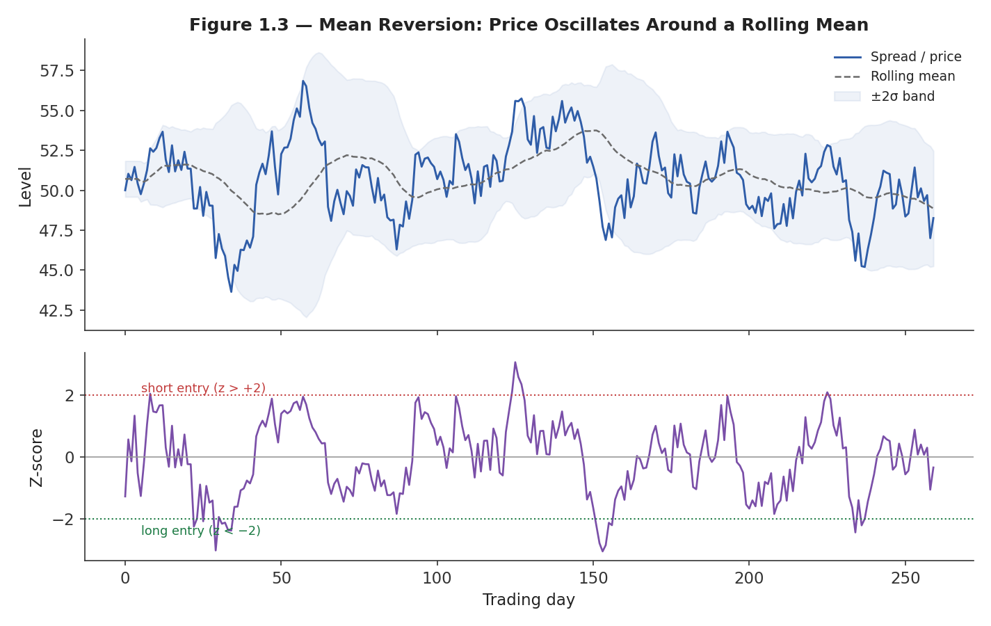
Figure 1.3 — A mean-reverting series oscillates around a rolling mean; a simple strategy shorts when the z-score is extreme and positive, and goes long when it is extreme and negative, closing the position as it reverts toward zero.
The economic rationale is different from momentum's: mean reversion typically arises from liquidity provision and temporary demand/supply imbalance rather than information diffusion. A large sell order pushes a price briefly below fair value; market makers and mean-reversion traders who step in to absorb that imbalance are compensated (via the eventual reversion) for providing liquidity when others needed to trade urgently. This is why very-short-horizon mean reversion is closely tied to the market microstructure concepts of adverse selection and market impact covered elsewhere in the curriculum — the reversion is, in a real sense, the market's price recovering after temporarily accommodating an impatient trader.

1.4 Reconciling Momentum and Mean Reversion: The Horizon Spectrum
Momentum and mean reversion are not contradictory once horizon is made explicit: return predictability changes sign as the measurement horizon lengthens, a pattern that has been documented repeatedly across markets and time periods.
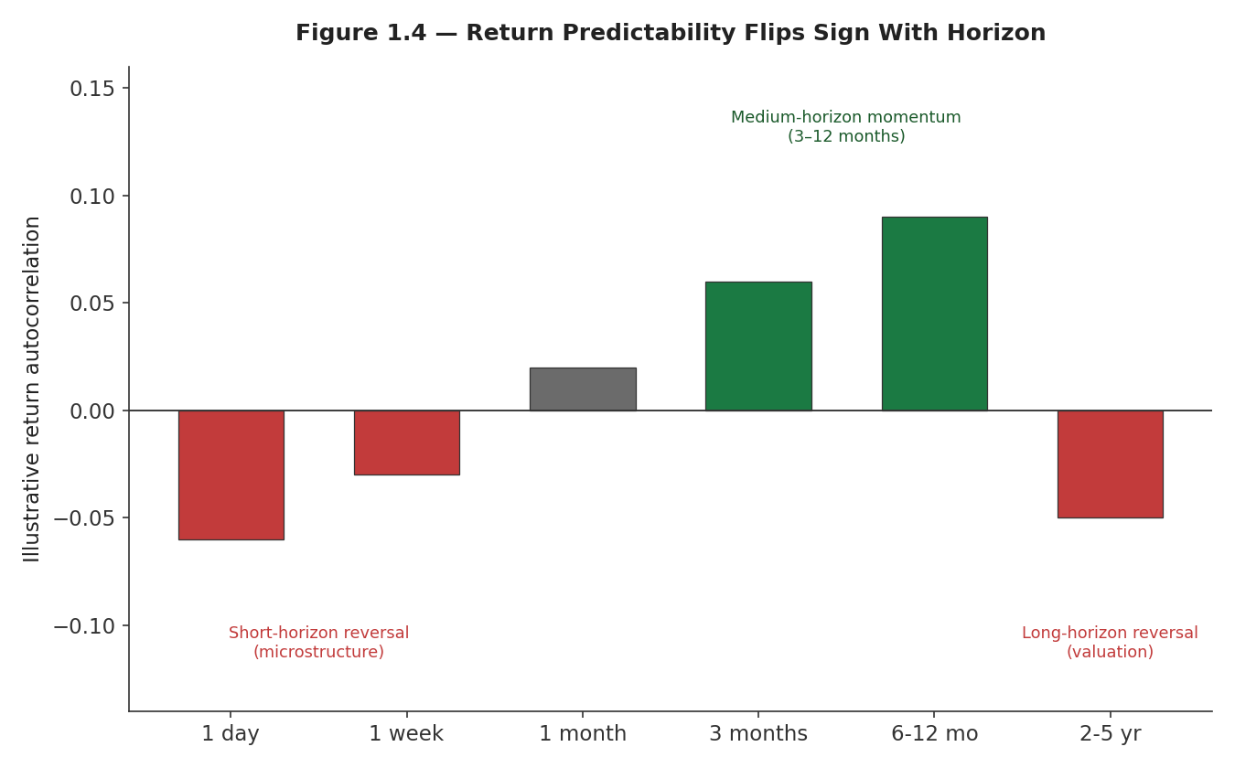
Figure 1.4 — Illustrative pattern of return predictability by horizon: short-horizon reversal (driven by microstructure and liquidity effects), medium-horizon momentum (3–12 months, driven by underreaction), and long-horizon reversal (multi-year, driven by valuation mean reversion as extreme prices eventually correct).
The practical implication is that 'is this asset class mean-reverting or trending' is the wrong question — the right question is 'over what horizon, and through what mechanism.' A single price series can be exploited by a mean-reversion strategy at a one-day horizon, a momentum strategy at a six-month horizon, and a value-style mean-reversion strategy at a five-year horizon, all three built on entirely different economic rationales and entirely uncorrelated with each other.

Part 2 — Pairs Trading and Statistical Arbitrage
This part generalizes single-asset mean reversion (Section 1.3) to a relationship between two or more assets — trading the spread rather than the level, which is the foundation of market-neutral relative-value investing.

2.1 The Pairs Trading Framework
Pairs trading identifies two securities whose prices have historically moved together — often because they share a common economic driver (two oil majors, two regional banks, an ETF and its constituent basket) — and trades the spread between them: long the relatively cheap one, short the relatively expensive one, betting the spread reverts to its historical relationship. Because the position is long one asset and short another with a similar risk profile, much of the common, market-wide risk cancels out, leaving a position that profits primarily from the relative move.
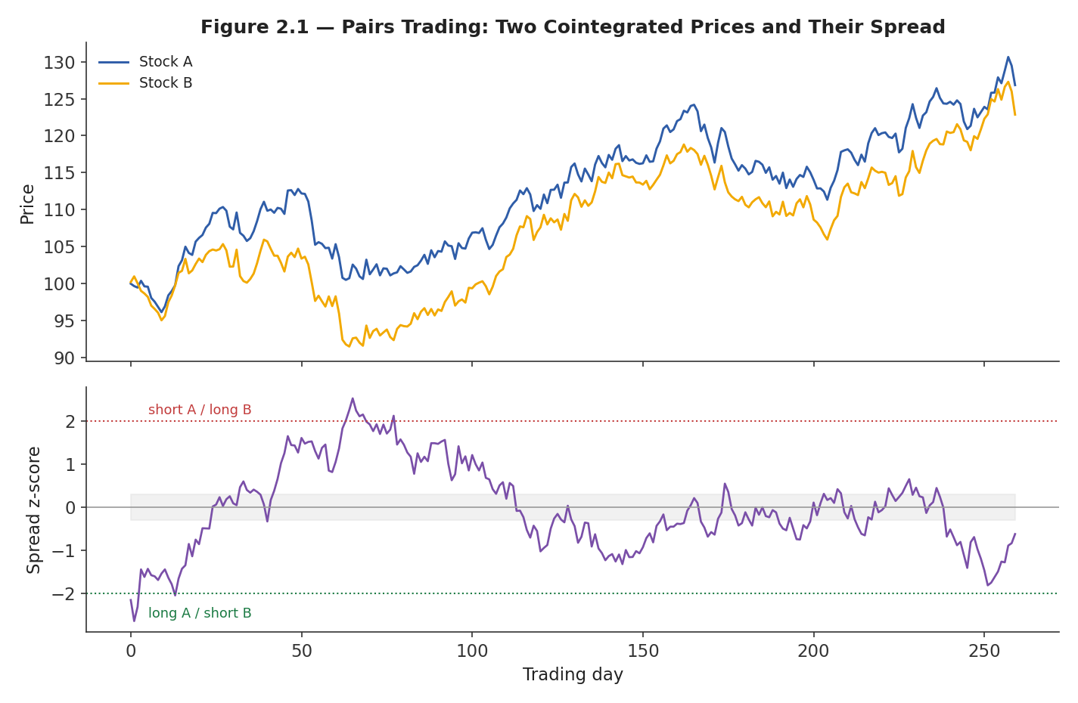
Figure 2.1 — Two related stocks (top) move together over time but drift apart temporarily; the spread between them (bottom, as a z-score) mean-reverts, generating long/short entry and exit signals.
Spread(t) = log(Price_A(t)) − β × log(Price_B(t)), where β is estimated by regressing A on B
The economic rationale is the same liquidity-provision and temporary-imbalance logic as single-asset mean reversion, applied to a relationship rather than a level: if two economically linked securities' prices diverge because of a temporary, security-specific demand shock (a large fund needing to sell one but not the other), a pairs trader who steps in to buy the cheap leg and sell the expensive leg is compensated as that imbalance unwinds.

2.2 Cointegration, Spread Construction, and Half-Life
Not every pair of correlated prices makes a good pairs trade — correlation of returns is common and often spurious, while cointegration (a property of the price levels, not the returns) is the more rigorous requirement: two non-stationary price series are cointegrated if some linear combination of them is stationary, meaning the spread itself reliably reverts to a stable long-run relationship rather than wandering off indefinitely.
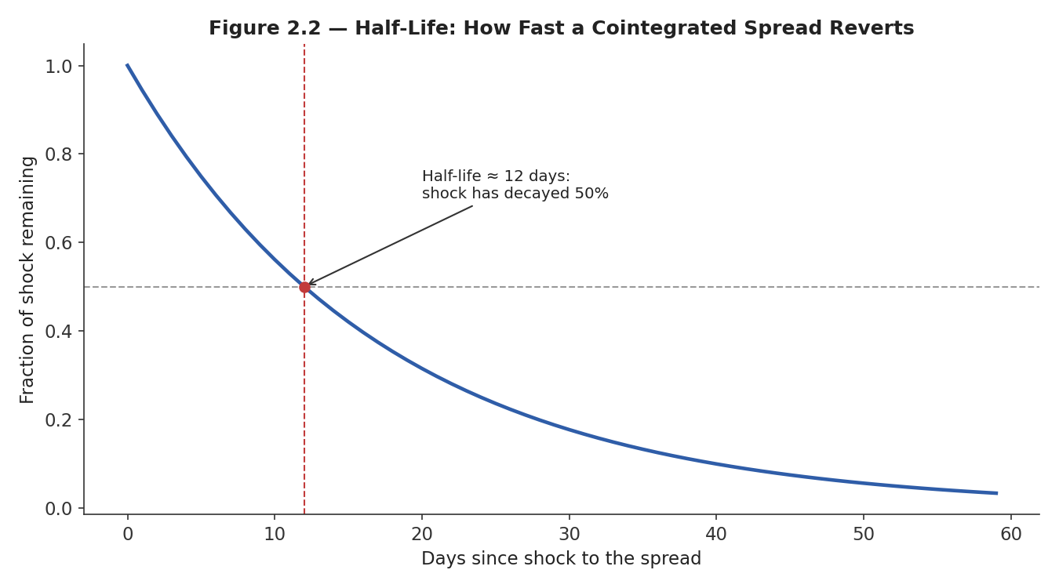
Figure 2.2 — The half-life of mean reversion measures how quickly a shock to the spread decays; a shorter half-life implies a faster-reverting, higher-turnover, generally higher-capacity-constrained trade.
The half-life of mean reversion — how long it takes a shock to the spread to decay by half — is a critical, often under-appreciated design parameter: a very short half-life implies a fast, frequent, but easily-costed-away edge, sensitive to transaction costs and requiring tight execution; a very long half-life implies a slow-moving trade that ties up capital and risk budget for extended periods with the possibility the cointegrating relationship itself breaks down before the spread ever reverts.
# Simple cointegration check and half-life estimate
import numpy as np, statsmodels.api as sm
from statsmodels.tsa.stattools import adfuller

beta = sm.OLS(np.log(price_a), sm.add_constant(np.log(price_b))).fit().params[1]
spread = np.log(price_a) - beta * np.log(price_b)

adf_stat, p_value, *_ = adfuller(spread) # p_value < 0.05 suggests stationarity

# Half-life via AR(1) fit on the spread's changes
lag_spread = spread[:-1]
delta = spread[1:] - lag_spread
theta = -sm.OLS(delta, sm.add_constant(lag_spread)).fit().params[1]
half_life = np.log(2) / theta
Common mistake — Selecting pairs purely by correlation of historical returns rather than testing for cointegration of price levels. Two prices can be highly correlated in their day-to-day moves while still drifting apart without bound over time — correlation describes co-movement, not the mean-reverting relationship a pairs trade actually depends on.

2.3 Statistical Arbitrage at Scale
Statistical arbitrage (stat arb) generalizes pairs trading from a single hand-picked pair, chosen for an economic story, to hundreds or thousands of simultaneous relative-value positions, typically constructed and selected by a statistical model (clustering, PCA-based factor neutralization, machine-learning ranking) rather than by name-by-name fundamental reasoning. Individual position sizes are small and individually noisy, but diversification across a very large number of largely uncorrelated spreads is the actual source of the strategy's risk-adjusted return.
This is a fundamentally different operating model from the pairs trading of Section 2.1: capacity comes from breadth (trading many small positions) rather than depth (trading one large, high-conviction position); risk management is done at the portfolio level (factor exposures, sector neutrality, gross and net exposure limits) rather than at the level of any individual spread; and turnover is typically high, making transaction-cost modelling and execution quality (see the Market Microstructure module) a first-order determinant of whether a stat arb book is actually profitable after costs, not just before them.

Part 3 — Carry, Value, and Quality
These three strategy families are grouped together because each earns a return largely independent of any single price forecast: carry is earned from holding a position through time, value and quality are earned from a persistent characteristic of the asset itself, rather than from correctly predicting a specific price move.

3.1 Carry
Carry is the return earned simply from holding a position, if prices never move at all — the yield on a bond, the dividend on a stock, the interest-rate differential on an FX position, or the roll return on a futures contract as it converges to spot. A carry strategy goes long high-carry assets and short (or underweight) low-carry assets, betting that the carry differential persists at least on average, even though any individual position can lose money from adverse price movement that swamps the carry earned.
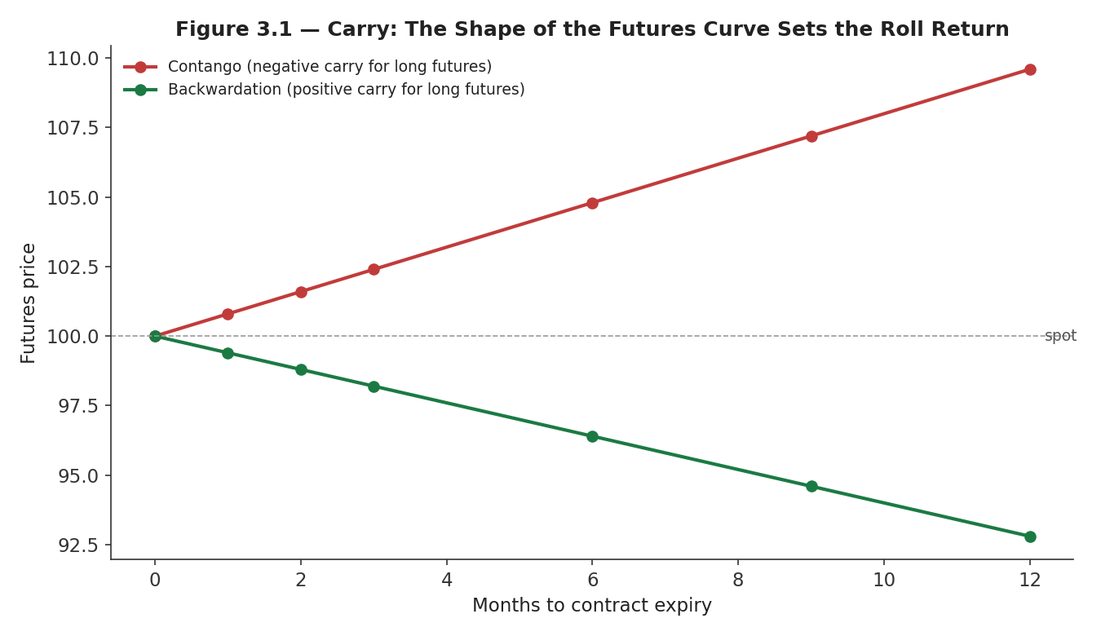
Figure 3.1 — The shape of a futures curve determines carry: in contango (upward sloping), a long futures position rolls down the curve at a loss (negative carry); in backwardation (downward sloping), it rolls up at a gain (positive carry).
Futures carry return ≈ (Spot − Futures price) / Futures price, annualized over the time to expiry
The economic rationale is compensation for risk: high-carry currencies are typically those of countries with higher inflation and default risk; backwardated commodity futures often reflect near-term scarcity and the convenience yield of holding physical inventory; high-dividend-yield stocks can reflect mature, lower-growth (and sometimes higher-distress-risk) businesses. Carry strategies are notorious for a specific risk shape: steady, positive returns most of the time, punctuated by sharp, correlated losses exactly during liquidity crises or risk-off events — the FX carry trade's repeated, sudden unwinds are the textbook example.

3.2 Value
Value strategies buy assets that are cheap relative to a fundamental anchor — price-to-earnings, price-to-book, EV/EBITDA, or a discounted-cash-flow estimate of intrinsic worth — and sell or underweight those that are expensive on the same measure, betting that the market's assessment converges toward fundamentals over time.
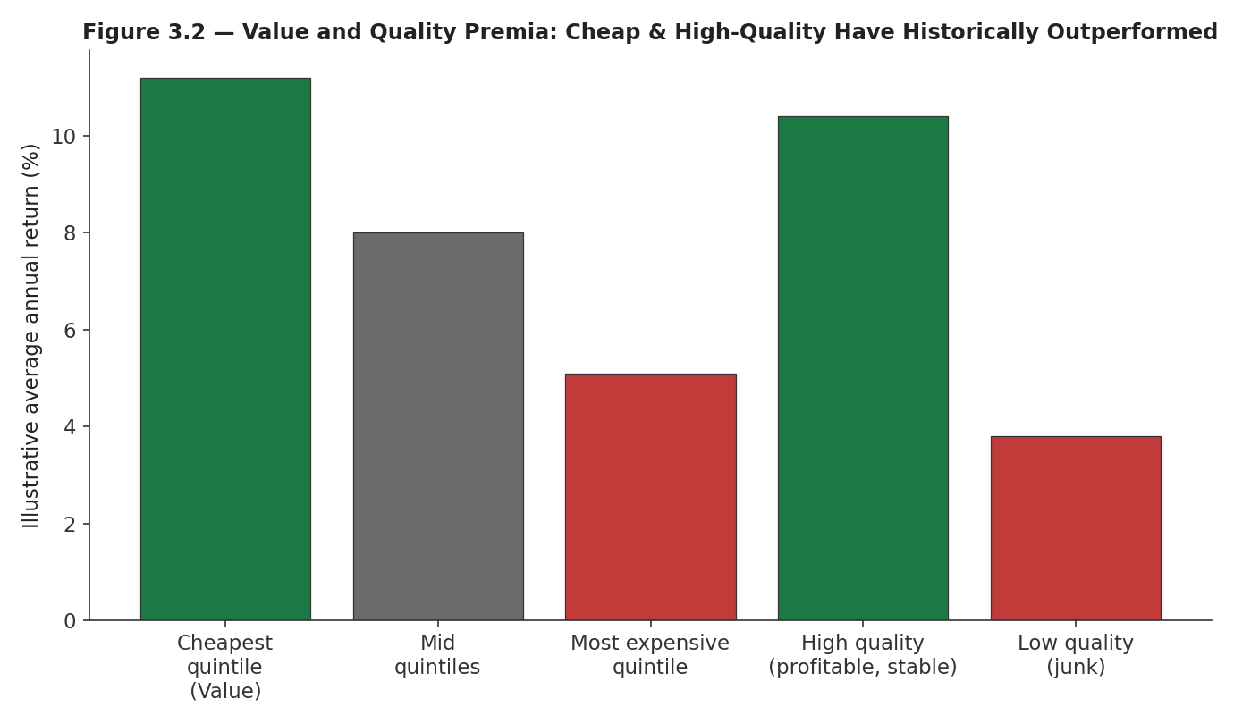
Figure 3.2 — Historically, the cheapest quintile of stocks by valuation (value) and the highest-quality quintile by profitability and stability (quality) have outperformed their respective opposite quintiles on average, though both premia are cyclical and can underperform for extended periods.
The economic rationale has two competing schools: a behavioral account holds that investors systematically overpay for exciting growth stories and underpay for boring, cheap businesses, correcting only slowly; a risk-based account holds that cheap assets are cheap because they are genuinely riskier (higher financial distress probability, more cyclical earnings), and the value premium is simply compensation for bearing that risk. Both accounts predict a positive long-run premium; they disagree on whether that premium should be thought of as a 'free lunch' correcting a market mistake, or as fair compensation for risk that will materialize in exactly the environments (recessions, credit stress) where diversification is needed most.

3.3 Quality
Quality strategies favor financially healthy, stable, consistently profitable businesses — high and stable margins, low leverage, low earnings volatility, high asset turnover — largely independent of how cheap or expensive the market currently prices them. A common construction, popularized in the asset-pricing literature, longs a quality-minus-junk portfolio: high-quality companies minus low-quality ('junk') companies, matched for size and often for valuation.
Simple quality score = weighted combination of profitability, earnings stability, leverage (inverted), and payout consistency
The economic rationale is closely related to value's risk-based account but points the opposite direction: quality is, in a sense, insurance against the specific risks that make junk stocks cheap in the first place — leverage, earnings volatility, and financial fragility — and investors are willing to pay a premium (accept a lower expected return) for that safety, which is precisely why quality and value can be combined: buying cheap, high-quality businesses avoids the classic 'value trap' of a stock that is cheap because it is a genuinely deteriorating business.
Tip — Value and quality are frequently combined rather than run separately, precisely because cheap alone is not a positive signal — a stock can be cheap because the market has correctly identified it as low quality. Screening for cheap-and-high-quality (or explicitly neutralizing value exposure to quality, and vice versa) is standard practice in most professional implementations of either factor.

Part 4 — Volatility and Event-Driven Signals
This part covers two strategy families that trade on dimensions other than the direction of an asset's price: the price of volatility itself, and the market's reaction to discrete, identifiable events.

4.1 Volatility Signals
The best-documented volatility signal is the volatility risk premium: the tendency of option-implied volatility (the market's forward-looking price of volatility) to exceed the volatility subsequently realized by the underlying asset, on average. A strategy that systematically sells volatility (e.g., writing options or holding short variance-swap positions) harvests this premium — profitably, most of the time, with the emphasis on most.
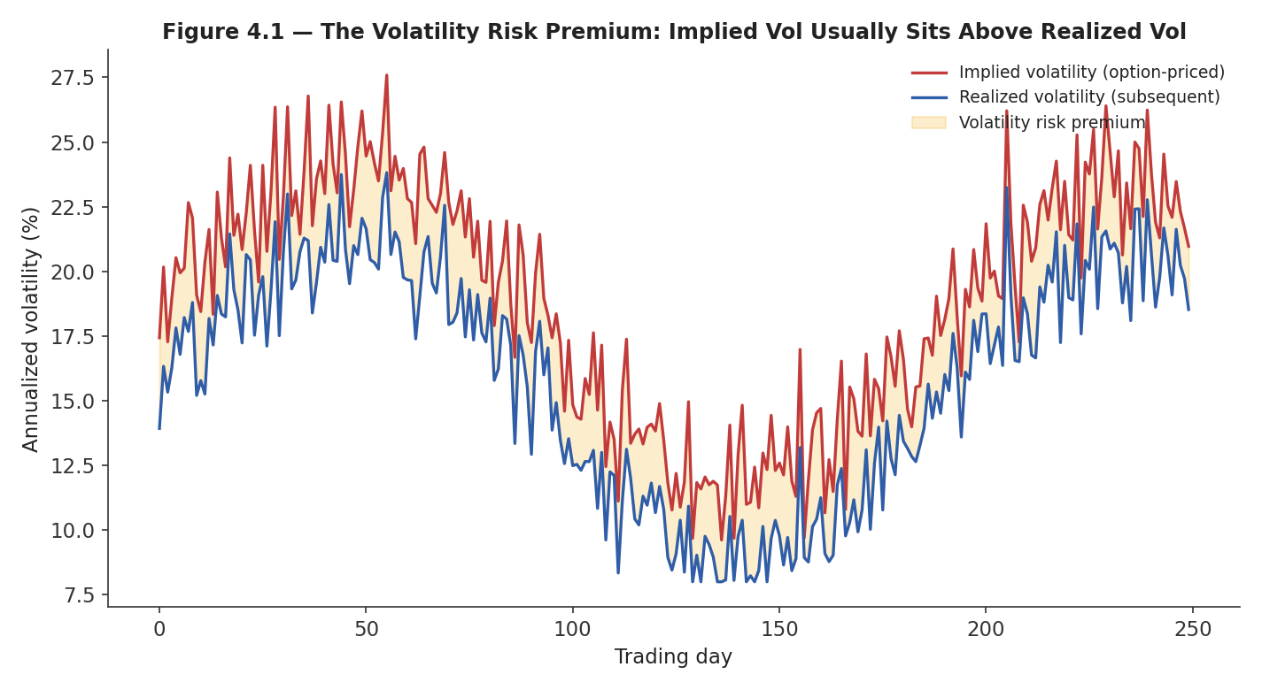
Figure 4.1 — Implied volatility (priced into options today) typically sits above the volatility subsequently realized by the underlying asset — the shaded gap is the volatility risk premium a volatility seller collects on average.
The economic rationale is the mirror image of insurance: option buyers are willing to pay a premium above the 'actuarially fair' price of volatility to protect against tail risk (large adverse moves), and volatility sellers are compensated for underwriting that insurance. This is why volatility-selling strategies exhibit a highly asymmetric, negatively-skewed payoff — small, steady gains most of the time, and infrequent, sharp losses exactly when realized volatility spikes far above what was priced in, which is also, not coincidentally, when the rest of a typical portfolio is also under stress.
Common mistake — Evaluating a volatility-selling strategy purely on its historical Sharpe ratio without stress-testing it against a realized-volatility spike. A strategy with an excellent multi-year Sharpe ratio built entirely from harvesting the volatility risk premium can be wiped out, or worse, in a single tail event — the strategy family's defining risk, not an incidental one.

4.2 Event-Driven Signals
Event-driven signals are keyed to a discrete, identifiable event — a scheduled earnings announcement, an M&A deal announcement, an index addition or deletion, a credit-rating change — rather than to the continuous evolution of a price series. The best-documented example is post-earnings-announcement drift (PEAD): stocks that report a positive earnings surprise continue, on average, to drift upward for weeks afterward, and those with a negative surprise continue drifting downward.
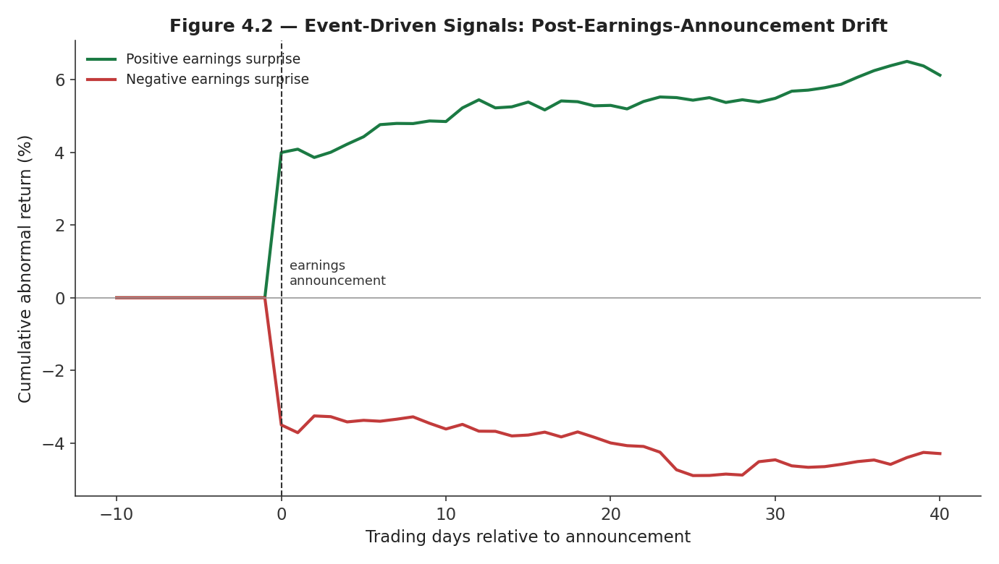
Figure 4.2 — Post-earnings-announcement drift: the cumulative abnormal return following a positive earnings surprise (green) continues to rise for weeks after the announcement, and the reverse for a negative surprise (red) — a slower adjustment than a fully efficient market would predict.
The economic rationale again centers on underreaction — analysts and investors adjust their models and positions gradually after new information, particularly information (like an earnings number relative to a consensus estimate) that requires interpretation rather than being immediately and unambiguously priced. Event-driven strategies differ operationally from the continuous-signal families above in an important way: position-entry timing is dictated by the calendar of events rather than by a model's own schedule, which concentrates risk around specific dates and requires infrastructure that can react quickly and correctly to scheduled and unscheduled announcements alike.

Part 5 — Seasonality, Relative Value, and Cross-Venue Arbitrage
This closing part covers three further families: patterns tied purely to the calendar, the broad category of relative-value and funding trades, and arbitrage across venues rather than across time.

5.1 Seasonality
Seasonality strategies exploit recurring, calendar-linked patterns in returns — turn-of-month effects, day-of-week effects, the historical tendency for certain months to outperform others — that are not obviously tied to any single fundamental event, but recur with enough regularity across history to be tradeable.
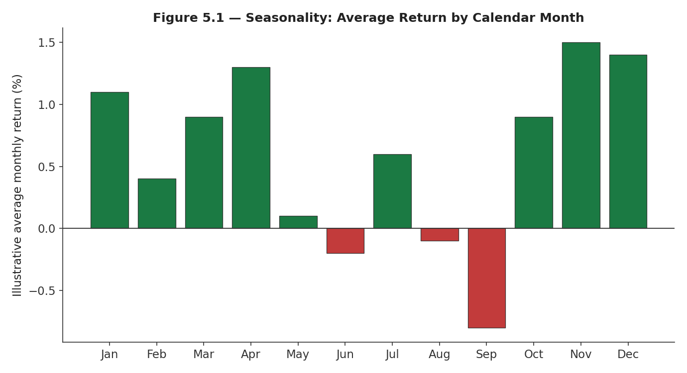
Figure 5.1 — Illustrative average monthly return pattern. Genuine seasonal effects are typically small, require long histories to distinguish from noise, and are among the strategy families most vulnerable to pure data mining.
Economic rationales for seasonality are generally weaker and more contested than for the other families in this module — proposed explanations include institutional flow patterns (month-end and quarter-end rebalancing by funds, tax-related trading near year-end, holiday-related liquidity effects), but the line between a genuine, persistent calendar effect and a coincidental pattern found by testing many possible calendar splits is thin. Seasonality is therefore the strategy family where the Understand Before Proceeding warning about data mining applies with the most force: a plausible-sounding institutional-flow story should be treated as necessary, not sufficient, justification.

5.2 Relative Value, Basis Trading, and Funding Arbitrage
Relative value is the broad umbrella covering any strategy that trades the price relationship between two related instruments rather than taking an outright directional view on either — pairs trading (Part 2) is one instance of it; basis trading and funding arbitrage are two further, mechanically simpler instances that rely on structural, near-arbitrage relationships rather than statistical estimation.
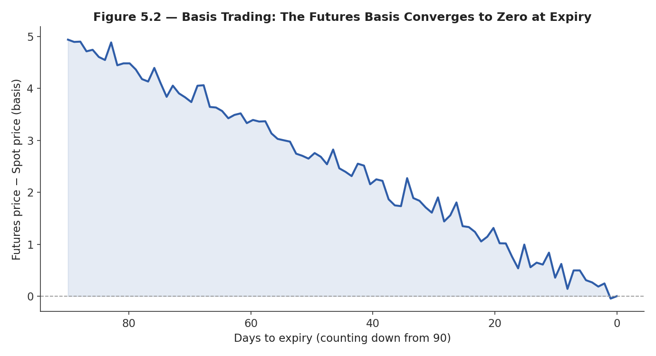
Figure 5.2 — A futures contract's basis (futures price minus spot price) must converge to zero by expiry, since the futures contract and the underlying asset become the same thing at that moment; a basis trade captures this convergence.
Cash-and-carry basis trade: long spot + short futures, captures the basis as it converges to zero by expiry, funded by any carry cost
Funding arbitrage is the closely related, increasingly prominent strategy of capturing the periodic funding-rate payment on perpetual futures contracts (common in crypto markets, and structurally similar to swap-based products elsewhere) by holding a position in the perpetual future offset by an opposite position in the underlying spot asset — a close-to-market-neutral trade whose return is the funding payment itself rather than any price appreciation. Both basis trading and funding arbitrage rely on a structural convergence guarantee (contract expiry, or the funding mechanism's designed effect of tethering the perpetual price to spot) rather than on a statistical estimate that might simply be wrong, which is what distinguishes them from the more model-dependent relative-value trades of Part 2 — though execution risk, margin requirements, and counterparty/exchange risk remain real and, in the case of funding arbitrage across less-regulated venues, can be substantial.

5.3 Cross-Venue Arbitrage
Cross-venue arbitrage captures temporary price discrepancies for the same, or an economically identical, instrument trading simultaneously on two or more venues — the same stock listed on two exchanges, the same cryptocurrency trading on two exchanges, or a security and its close economic equivalent (an ETF and its underlying basket) momentarily priced inconsistently with each other.
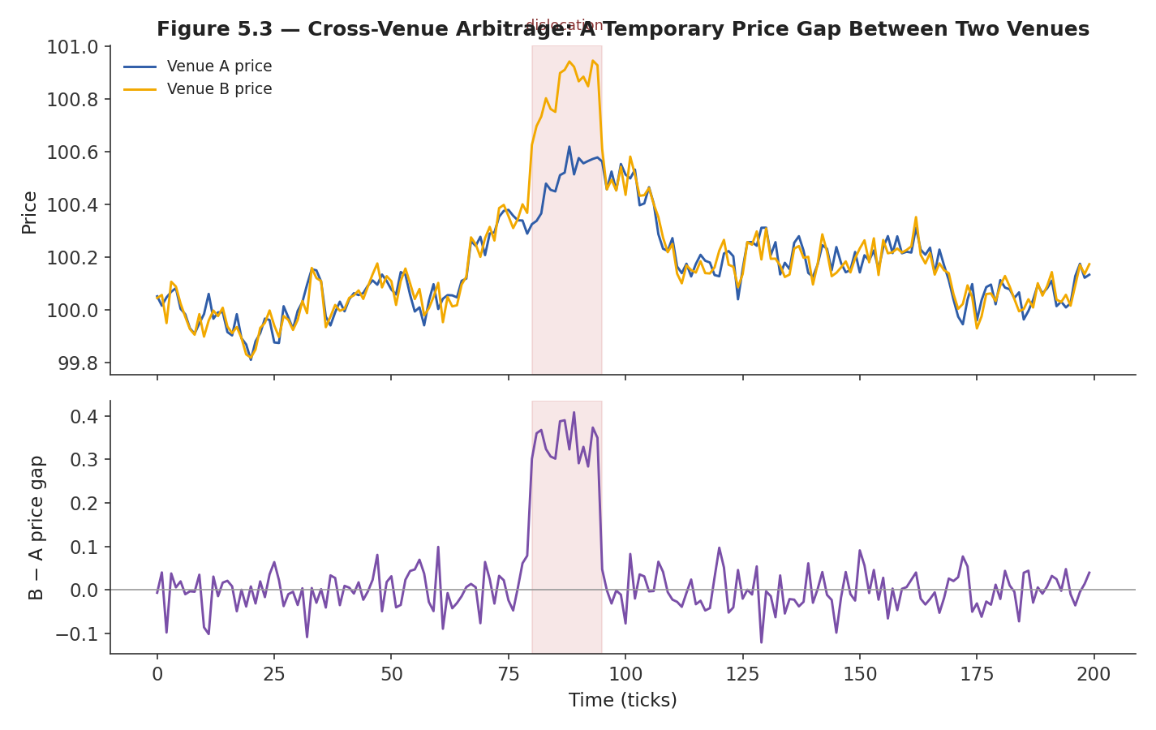
Figure 5.3 — A temporary price dislocation between two venues (top) creates a brief arbitrage opportunity, visible directly as a nonzero price gap (bottom) that a fast participant can capture before it closes.
The economic rationale requires no story about underreaction, risk premia, or investor behavior at all — it is the most literal form of arbitrage in this module, a genuine, if fleeting, violation of the law of one price, caused by temporary segmentation of order flow across venues (a large order hitting one venue before liquidity providers on the other venue can react) rather than by any information or valuation disagreement. Precisely because the opportunity requires no economic insight, it is captured entirely by speed: this is the strategy family most directly connected to the latency concepts in the Market Microstructure module, and the one where being a few microseconds slower than a competitor can be the entire difference between a profitable and a nonexistent edge.
Common mistake — Ignoring that different families decay and crowd at very different rates. A cross-venue arbitrage opportunity, once discovered, can be arbitraged down to near-zero within months by faster, better-capitalized competitors, because the opportunity is public and mechanical; a novel relative-value trade built on a genuinely under-appreciated economic relationship, or a slow-moving factor like value, can persist for years or decades, because it requires real analytical insight — or real patience through periods of underperformance — to exploit, which limits how quickly capital can pile in.

Practical Exercise
Pick one strategy family from this module, write its economic rationale in one paragraph, then implement a simple version and evaluate it against the backtesting checklist below.

Backtesting checklist (Part III reference)
- Economic rationale stated first — write the one-paragraph rationale before looking at any results; if the backtest is disappointing, you should be able to say whether that contradicts the rationale or is consistent with it.
- Out-of-sample validation — hold out a final period of data never touched during signal design, and check performance only once, at the end.
- Realistic transaction costs — apply spread, market-impact, and (where relevant) financing cost assumptions appropriate to the strategy's turnover and typical trade size (see the Market Microstructure module).
- Capacity estimate — approximate how much capital the strategy could absorb before its own trading materially erodes the edge.
- Decay and crowding assessment — identify what would cause this specific edge to shrink (more competition, a regime change, the underlying mechanism breaking down) and whether that is already visible in the more recent part of the data.
- Risk-adjusted evaluation — assess Sharpe ratio, maximum drawdown, and skewness/tail behavior, not just average return; several families in this module (carry, volatility selling) have return profiles that look excellent by average return alone while hiding significant tail risk.
# Skeleton for the practical exercise
# 1. State the economic rationale (as a comment, in your own words)
# rationale = "..."

def build_signal(data):
# implement a simple version of the chosen strategy family
...

def backtest(signal, prices, cost_bps=5):
returns = signal.shift(1) * prices.pct_change()
turnover = signal.diff().abs()
costs = turnover * (cost_bps / 10_000)
return returns - costs

# Evaluate: Sharpe ratio, max drawdown, out-of-sample split,
# capacity approximation, and a written decay/crowding assessment.

Common Beginner Mistakes
- Building a strategy purely because it 'backtests well' with no economic story for why the edge exists — the single most important mistake this module addresses; a story does not guarantee an edge is real, but the absence of one is a strong warning sign.
- Ignoring that different families decay and crowd at very different rates — treating a fast-crowding cross-venue arbitrage opportunity with the same durability assumptions as a slow-moving value premium, or vice versa.
- Testing many variations of a signal on the same data until one looks good, without correcting for the resulting multiple-testing bias.
- Evaluating carry and volatility-selling strategies by average return alone, without stress-testing the tail scenario each family is structurally exposed to.
- Assuming a strategy family that works in one asset class (e.g., equities) will transfer unchanged to another (e.g., crypto or FX) without re-examining whether the underlying economic rationale still applies.

Advanced Extensions
The following is a Level 3–5 topic, introduced here only by name so you know what to look for when you reach it:
- Combining multiple uncorrelated strategy families into a diversified signal portfolio — allocating risk across families whose economic rationales, decay profiles, and crash risks are as uncorrelated as possible, so that the failure mode of any one family (a momentum crash, a volatility spike, a crowded arbitrage unwind) does not dominate the overall book.

Professional Applications
- Systematic hedge fund strategy books — most multi-strategy systematic funds are, structurally, a portfolio of several of the families in this module, risk-allocated according to their correlation and capacity characteristics.
- Prop-trading signal libraries — proprietary trading desks maintain internal libraries of signals organized along exactly these family lines, so that a new signal can be evaluated against 'is this genuinely new, or a restatement of a family we already run.'

Where to Go Next
This module surveyed each strategy family at the level of its economic rationale, canonical construction, and worked example. Part III of the curriculum returns to each family with its own dedicated data-sourcing, signal-construction, and validation methodology in full depth, and the Risk Metrics and Execution Algorithms modules cover how these signals are sized, combined, and actually traded once selected.

